Oscillator-Driven Inductive-Link Wireless Power

Christopher A. Tucker, University of Reading, UK

**Keywords:** power electronics, wireless energy transfer, oscillators

Abstract

Models of wireless energy transfer have been rife in the literature describing the method and means of power transfer which have shown themselves as viable. However, what is lacking is the inclusion of the manner in which the energy is driven. Most only briefly describe this driving force as an “external source”. This paper will address a model of wireless energy transfer which utilizes a tank circuit acting in itself as source using only an onboard amplifier package which results in a powerful, highly efficient and small set of components.

Preliminary To do

Program  to the circuit calculator and generate the final result. FINIS Program the radiation resistance, input how Q is calculated. Also program the spiral L, however leave all these here as it is for now but program before returning to “oscillator” paper. DONE

Next is to add the enhancements and intersect this with the robot paper.

**Introduction**

As wireless energy transfer becomes more popular, it is necessary to establish a set of generalizations regarding specific configurations of machines. This paper will only concern itself with an examination of the inductive link model of wireless energy transfer using magnetic resonances which utilizes a pair of coils, one acting as a transmitter or primary coil, the other as a receiver or secondary coil. It will also examine multiple receivers of the same type.

As the diameter increases towards a wavelength (lambda = c / f), loss due to electromagnetic radiation will become significant.

**Power Efficiency in Inductive Link Models**

The model exhibited in this paper will be the inductive link model. The model assumes the relationship between a primary and secondary coil set apart at a distance, as shown in Figure 1.

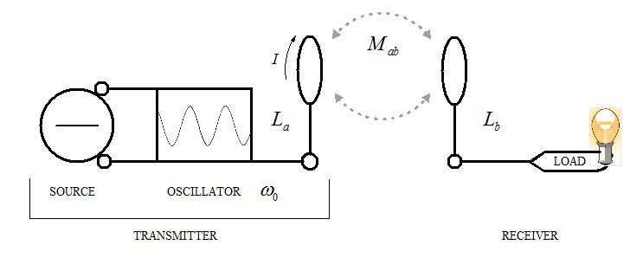

Fig. 1: The Inductive Link Model of Parallel Resonant Circuits

In order to analyze if the regime is suitable for usage in a scheme, the criteria by which this is judged is to examine the model in terms of its overall efficiency, that is, by a comparison between the energy that is input and the energy output. The author believes it is this criteria and this criteria alone that will be the means by which differentiating models will be judged to be used in commonplace applications which range from consumer to medical to defense. As such, the system under consideration has been designed with extreme optimization in mind and each component chosen for maximum performance in context with the others. Therefore, the purposeful choice of using the type of oscillator described herein is not by accident, rather, it has been discovered but not covered in the scope of this paper it is ideal considering its size.

The efficiency of the model is measured by the equation:



Where the power transfer efficiency  is a strong factor of the coupling coefficient , and the quality factor, , of the transmitter coil  and the receiver coil .

Coil Properties

The resonance frequency of the model is calculated by the equation:



And the frequency error between each half of the circuit:



As the resonant circuit transmitter coil  and its capacitance  are parallel to the oscillator in Fig. 1, and that it is loaded by the receiver coil  and its capacitance  parallel to the load, the calculation of the quality factor :



The maximum energy stored in  and C is:



Alternatively [CHECK THIS EQUATION IN THE CALCULATOR]:



where  and .

Q = R / X

R = parallel load resistance  
X = reactance in ohms

To calculate reactance:

XL = 2piFL or XC = 1 / 2piFC

2pi = 6.28  
F = frequency in hertz  
L = inductance in henrys  
C= capacitance in farads

Example: Calculate Q for a 14.128 MHz loaded parallel resonant circuit where L = 2.7 microhenrys and R is 18 kilohms.

Q = 18000 / (6.28 * 14128000 * .0000027)

Q= 75.1

Adding resistance to a parallel resonant circuit will decrease Q and increase bandwidth.

In loaded resonant circuits, the circuit delivers power to a load. The power dissipated by the resistance of the resonant circuit is negligible in comparison.

The mutual coupling  between the coils is a function of the alignment and distance between the coils. This coupling is highly dependent upon the properties of the coils, that is, the mutual inductance between the inductance of primary  coil and secondary  coil as:



While (2) will provide an approximation of the mutual inductance, it is more interesting to understand the means by which this value is generated by the system by the magnetic flux linkage  between the primary coil and the secondary coil. As the coupling coefficient is not known in advance, it is necessary to first solve for the mutual inductance .[1]



Where  is the area of the receiver coil, **B** is the magnetic field, is the current passing through the transmitter coil, **n** is the normal vector to the plane of the coil, and  is an infinitesimal area element. The mutual inductance, along with the energy stored will show a field object containing the exchange of energy between the coils.[2] In the model herein, the primary is generating the electromagnetic emissions and projecting them into free space along the x-axis. [Needs to be finished.]

[DUCK]

Referring to the scheme illustrated in Fig. 1, the coupling coefficients between the magnetically-coupled coils are defined as



where  is the mutual inductance, ,are the self-inductances of the distant coils. Since we cannot calculate the coupling coefficient directly, we will need to calculate the inductances and the mutual inductance of the distant coils flowing with the current . For the coils  and , we will use the approximation for the inductance of a circular loop[3]



where  is the loop radius and  is the wire radius,  is the number of turns, and  is the flow constant of the skin-effect of the emitted radiation from coil .

Distance

To insure maximum performance, the power-transfer efficiency  verses the normalized distance  (the ratio of separation between the coils and the geometric mean of the primary and secondary coil radii  will be the measure of this maximum gradient along the length away from the coil along the x axis, referring to Figure 1. It is the gradient that will be analyzed experimentally in the next section.

[DUCK]

The potential coupling  changes the further the distance  away as a measure of 1-dimensional coordinates along it. This is visualized as:

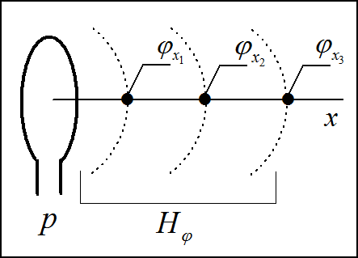

Fig. 2: Propagation of Magnetic Currents

In the space containing the energy, the intensity of the magnetic field can be known in advance given the distance between the coils and the radius of the primary coil. In a multiple-turn Litz-wound coil of turns  with radius , the magnetic field strength  at distance  from the center of the coil along the axis can be written as[4]:



Differentiating with respect to  shows that for ,  will be maximized. Therefore, a good choice of diameter  for the primary coil, as a measure of its distance  from the secondary coil  is . In the design chosen for experimental verification, the diameter = 60mm while the distance = 20mm. While this will show an optimal value, the maximum range of this design is approximately 45mm, dependent upon the oscillator power driving the coil. The magnetic flux linkage and field intensity at the optimal distance is illustrated by Figure 2.

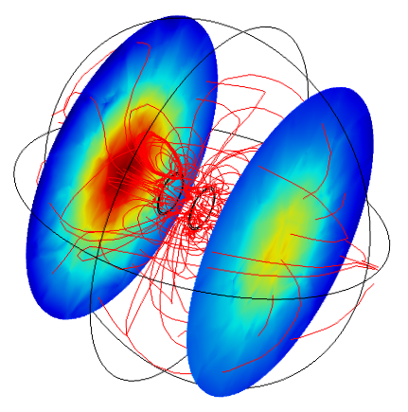

Fig. 3: Magnetic Linking (red lines) and Field Intensity (colored disk)

The transmitter is to the left and the receiver is to the right.

**The Oscillator Model**

The push-pull oscillator is a balanced oscillator employing amplifying devices placed in phase opposition. It is a type of oscillator described in the 1940s in detail[5] using tubes.

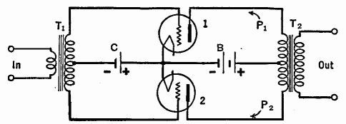

Fig. 4: Tube-Driven Push-Pull Oscillator

The circuit illustrated in Figure 3 is a transformer-coupled model. This type of circuit is able to deliver larger outputs with less distortion than single-tube amplifiers. Assume that a sine wave signal is applied to the input terminals. During the first half-cycle, the top of the secondary of transformer *Tt* becomes positive and the bottom becomes negative. Then the grid of tube 1 becomes positive and the grid of tube 2 becomes negative. The plate current of tube 1 increases and that of tube 2 decreases. But the current increase in *P1* is up and that in *P2* is down. If an *increase* in plate current through *P1* makes the output positive at the top, then a decrease in current through P*2* will also make the output positive at the top. Thus, the outputs of tubes 1 and 2 add together. DESCRIBE THIS IN TERMS OF THE MOSFET ARCHITECTURE.

It is necessary to alter it to have it behave as an inductive-link coupled model. Tuned-not-tuned?

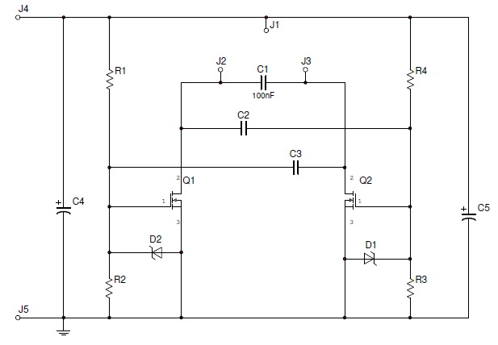

Fig. 5: Modified Circuit Diagram (switch D1 and D2 labels)

In this form, the transformers are split into two sequences, namely, the inductance contained in the primary coil  and the inductance contained in the secondary coil . Figure 5 shows a simple model of a receiver containing a load. The operation of the amplifiers are similarly tied across the circuit at each end of the primary coil at J2 and J3. Contrastingly, as tubes are unnecessary large, it is more advantageous to substitute them for MOSFET power amplifiers. They yield good performance and robust operation without high driving voltages and high heat emissions. Resistors R2 and R3 set the gain on the amplifiers while R1 and R4 isolate circuit polarity across the inductor. In this inductive link coupled form, the push-pull oscillator is a set of semiconductors providing amplitude to a RLC tank circuit.

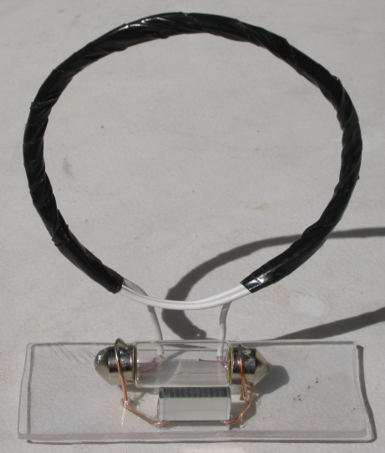

Fig. 6: Simplified Receiver Package with Lamp

Words.

**Experiment**

**Experimental Setup-Where does this passage come from?**

Tests carried out with a Hewlett-Packard 4192A Impedance Analyzer show the reactance of the coils to be

show that even with low-*Q* factor driver and load coils (≈ 0.6,  ≈ 0.3, referring to Table III) and low coupling between primary and secondary coils ( ≈ 0.03), more than 60% efficiency can be achieved using a moderate coupling of  and  (*∼*0.3) and a moderate-*Q* (*∼* 35) primary and secondary coils. Using four-coil power transfer system with high-*Q* factor (*∼*600 to 1000) results in more than 90 % efficiency over a relatively long distance (*R ≥* 2). Figure 3 shows that given realistic values for parameters , , , and  the overall efficiency is maximized near *R ∼* 2*.*5 by using high-*Q* coils b and c. By adjusting , , , and  one can also adjust the distance *R* at which the  is maximum.

The designed circuit

The experiment will examine two (three) radial means to examine what are the limitations in  as a property of the coil geometry and distance between the transmitter  and receiver .[6] Also, as a measure of the work that is done at the load contained in  the load will consist of 1) an incandescent lamp, and 2) a motor.

The lamp, shown contained in the receiver circuit illustrated in Figure 5, is a commonly-available type used in automotive applications and is rated 5 watts at 12 volts.

Words.

To idealize this value as a function of

**While**

1. L. Hannakam, “Berechnung der Gegeninduktivitat achsenparalleler Zylinderspulen,” *Archivfiir Elektrotechnik,* vol. 51, no. 3, pp. 141-154, 1967.
2. J.H. Poynting, “On the Connection Between Electric Current and the Electric and Magnetic Inductions in the Surrounding Field”, Philosophical Transactions of the Royal Society, 176, pp. 277-306, (1885) .
3. R.S. Elliott, *Electromagnetics*. New York, IEEE Press, 1993. 
4. Paul, Reinhold (1993) *Elektrotechnik 1–Felder und einfache Stromkreise*, 3rd edn, Springer-Verlag, Berlin/Heidelberg.
5. J. Barton Hoag. *Radio Elementals*. 1942.
6. RamRakhyani, et. al.